CMPG 325 – Computer Networks
Individual Semester Project – Final Technical Report
Network Design and Implementation for Tau Metalworks & Engineering Supplies
Student | T. Magwatane (42710677)
Project ID | CMPG325-2026-034
Client ID | CLI-034
Client | Tau Metalworks & Engineering Supplies (Potchefstroom)
Addressing block | 172.30.16.0/23
Assigned challenge | HTTP/Web Server (internal web service hosting)
Design constraint | Availability of critical services during business hours
Change request | CR2 – additional floor
Submission date | 16 October 2026
Institution | North-West University

Table of Contents
1. Executive Summary 3
2. Introduction and Requirements 3
2.1 Client background 3
2.2 Requirements-to-implementation mapping 3
3. Network Design 4
3.1 Physical topology 4
3.2 Logical topology 4
3.3 Alternatives considered 5
4. IP Addressing Plan 5
5. Implementation 6
5.1 Packet Tracer topology 6
5.2 VLANs and trunking 7
5.3 Core switch and inter-VLAN routing 9
5.4 Centralised DHCP 9
5.5 HTTP/Web Server (assigned challenge) 14
5.6 LACP EtherChannel 16
5.7 Change request CR2 17
5.8 Management VLAN 17
6. Testing and Verification 18
7. Troubleshooting Log 19
8. Response to the Availability Constraint 20
9. Security and Management Considerations 20
10. Limitations and Future Work 21
11. Reflection 21
12. Conclusion 21
Appendix A: Device Inventory 21
Appendix B: Verification Commands 22

1. Executive Summary
This report documents the design, implementation, testing and evaluation of a computer network for a local area network for Tau Metalworks & Engineering Supplies, a manufacturing organisation in Potchefstroom. The network was designed within the assigned address block 172.30.16.0/23 and implemented in Cisco Packet Tracer. The assigned networking challenge, an internal HTTP/Web Server, is hosted in a dedicated server VLAN and was verified from three separate departmental VLANs.
The design follows a two-tier, extended-star hierarchy. A single Layer-3 multilayer Core switch performs inter-VLAN routing and provides centralised DHCP, while six Layer-2 access switches serve the Ground Floor, Engineering, Production, Warehouse, Server and CR2 areas. Eight VLANs segment the organisation, and the address block is divided using Variable Length Subnet Masking (VLSM). In response to the availability constraint, the server switch is connected to the Core through a two-link LACP EtherChannel, so that the failure of a single physical link does not interrupt the web service. The change request (CR2) was accommodated by adding one access switch and one VLAN without modification of the existing design.
Fifteen verification tests were performed, and all were recorded as passed on the basis of evidence captured in Packet Tracer. Items that were considered but not implemented (access control lists, DNS, a redundant Core) are identified explicitly in Section 10 as limitations.

2. Introduction and Requirements

2.1 Client background
Tau Metalworks & Engineering Supplies operates from a multi-department building and requires a reliable internal network that supports administrative work, sales, engineering, production, warehousing and an internal web service. The project brief assigned the address block, the networking challenge, a design constraint and a change request, summarised below.

2.2 Requirements-to-implementation mapping
Requirement | Source | Implementation
Address block 172.30.16.0/23 | Project brief | Divided by VLSM into six /26–/27 client subnets plus a /28 management subnet
HTTP/Web Server challenge | Project brief | SRV-HTTP at 172.30.17.66 in VLAN 60; page reachable from VLANs 10, 30 and 70
Critical services available during business hours | Design constraint | Server VLAN isolation; LACP EtherChannel (Po1) between Core and SW-SERVER
Additional floor | Change request CR2 | VLAN 70, 172.30.17.96/27, SW-NEWFLOOR on a standard trunk
Departmental separation | Milestone 1 design | VLANs 10, 20, 30, 40, 50, 60, 70, 99 with routed inter-VLAN traffic
Manageability | Milestone 1 design | VLAN 99 management addresses on all switches

3. Network Design

3.1 Physical topology
An extended-star topology was selected. The Core multilayer switch (CORE-SWITCH, Cisco 3560-24PS) forms the centre, and each floor or functional area connects to it through a dedicated Cisco 2960 access switch. Engineering and Production are served by separate switches (SW-ENG and SW-PROD), and the Ground Floor switch (SW-GROUND) carries both Administration and Sales on separate VLANs.
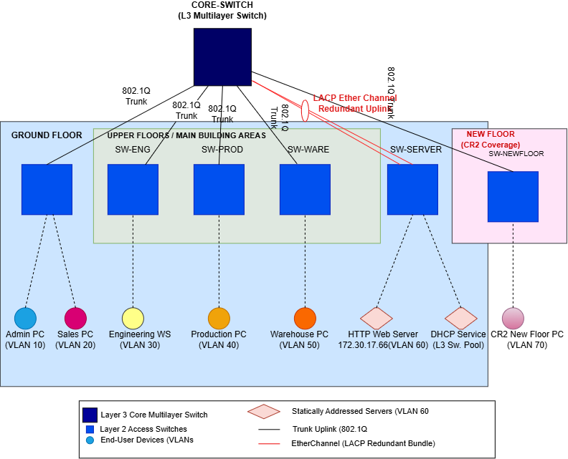
Figure 1: Physical topology (design diagram)

3.2 Logical topology
Each VLAN is a distinct subnet whose default gateway is a Switched Virtual Interface (SVI) on the Core. A device on an access VLAN reaches any other segment by crossing an 802.1Q trunk to the Core, where hardware-based inter-VLAN routing forwards the traffic to the destination VLAN.
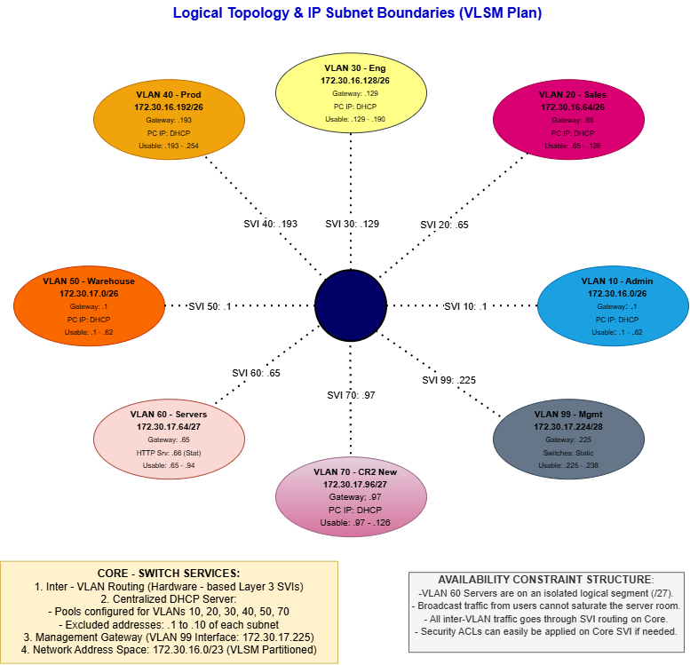
Figure 2: Logical topology (design diagram)

3.3 Alternatives considered
Alternative | Advantage | Reason for rejection
Flat single-switch network | Lowest cost and simplest configuration | Single point of failure; no broadcast isolation; conflicts with the availability constraint
Full-mesh switching | Maximum path redundancy | Cabling and configuration overhead disproportionate to organisation size; complicates CR2
Router-on-a-stick | Uses a conventional router | The Core multilayer switch routes in hardware and avoids a single router uplink as a bottleneck
Extended star (adopted) | Scalable, simple fault isolation, new floors added by one trunk | Core remains a single point of failure (see Section 10)

4. IP Addressing Plan
The /23 block (172.30.16.0 – 172.30.17.255, 512 addresses) was divided using VLSM. Larger /26 subnets (62 usable hosts) were allocated to the four principal departments and the warehouse, while the smaller server and CR2 segments received /27 subnets (30 usable hosts) and management received a /28 (14 usable hosts). The range 172.30.17.128 – 172.30.17.223 was left unallocated for growth.
VLAN | Department | Subnet | Usable range | Gateway (SVI)
10 | Administration | 172.30.16.0/26 | .1 – .62 | 172.30.16.1
20 | Sales | 172.30.16.64/26 | .65 – .126 | 172.30.16.65
30 | Engineering | 172.30.16.128/26 | .129 – .190 | 172.30.16.129
40 | Production | 172.30.16.192/26 | .193 – .254 | 172.30.16.193
50 | Warehouse | 172.30.17.0/26 | .1 – .62 | 172.30.17.1
60 | Servers | 172.30.17.64/27 | .65 – .94 | 172.30.17.65
70 | New floor (CR2) | 172.30.17.96/27 | .97 – .126 | 172.30.17.97
99 | Management | 172.30.17.224/28 | .225 – .238 | 172.30.17.225 (Core)

The DHCP service was configured on the Core switch to allocate IP addresses dynamically to client devices in VLANs 10 (Administration), 20 (Sales), 30 (Engineering), 40 (Production), 50 (Warehouse) and 70 (CR2/New Floor). The DHCP configuration excludes the relevant default gateway addresses and selected static addresses to reduce the risk of IP address conflicts. The HTTP server uses the static address 172.30.17.66 in VLAN 60, while the management interfaces use addresses in VLAN 99. The recorded DHCP leases demonstrate that client devices received addresses from their respective subnets. DHCP allocation was assessed by checking the assigned IP addresses, subnet masks and default gateways on the client devices and reviewing the DHCP bindings on the Core switch.
Device | Management IP (VLAN 99) | Role
CORE-SWITCH | 172.30.17.225 | Layer-3 Core
SW-GROUND | 172.30.17.226 | Access
SW-ENG | 172.30.17.227 | Access
SW-PROD | 172.30.17.228 | Access
SW-WARE | 172.30.17.229 | Access
SW-SERVER | 172.30.17.230 | Server access
SW-NEWFLOOR | 172.30.17.231 | CR2 access

5. Implementation

5.1 Packet Tracer topology
The completed implementation is shown below. All links were active (green) once the EtherChannel had formed.
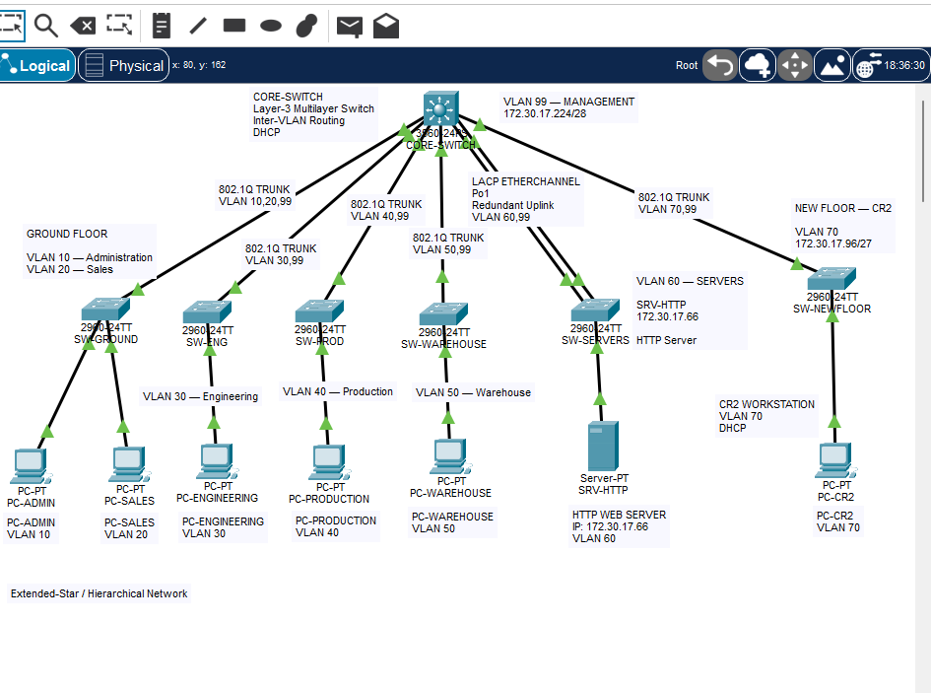
Figure 3: Completed Packet Tracer implementation

5.2 VLANs and trunking
Eight VLANs were created on the Core and on the access switches that use them. Every access uplink is an 802.1Q trunk with VLAN 99 as the native VLAN, and each trunk permits only the VLANs required by that area.
Trunk | Allowed VLANs | Native VLAN
CORE → SW-GROUND | 10, 20, 99 | 99
CORE → SW-ENG | 30, 99 | 99
CORE → SW-PROD | 40, 99 | 99
CORE → SW-WARE | 50, 99 | 99
CORE → SW-NEWFLOOR | 70, 99 | 99
CORE → SW-SERVER (Po1) | 60, 99 | 99

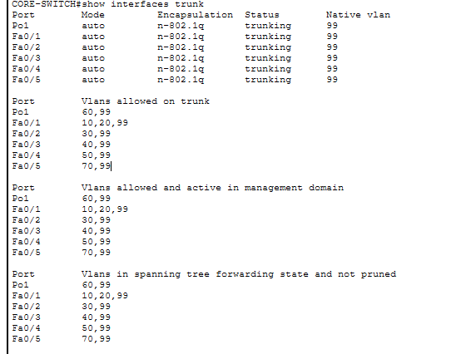
Figure 4: show interfaces trunk on the Core: Po1 and Fa0/1–Fa0/5 trunking, native VLAN 99, allowed VLANs as designed
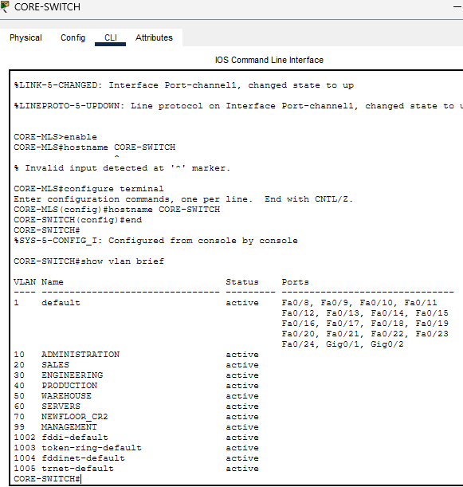
Figure 5: show vlan brief on the Core switch: all eight VLANs present
Figure 6: show interfaces trunk on the Core: trunk ports, native VLAN 99 and allowed VLANs (Po1 carries 60 and 99)

5.3 Core switch and inter-VLAN routing
IP routing was enabled on the Core and an SVI was created for each VLAN using the gateway addresses in Section 4. Representative configuration:
ip routing
interface vlan 10
ip address 172.30.16.1 255.255.255.192
no shutdown
interface vlan 60
ip address 172.30.17.65 255.255.255.224
no shutdown
interface vlan 99
ip address 172.30.17.225 255.255.255.240
no shutdown

5.4 Centralised DHCP
DHCP pools were configured on the Core for VLANs 10, 20, 30, 40, 50 and 70, each with its SVI as default router. The DHCP exclusion statements were configured according to the addresses reserved for default gateways and selected static devices. The configured exclusion ranges should be verified against the running configuration of the Core switch. The DHCP pools were then checked to confirm that client devices received addresses from the correct VLAN subnets.
ip dhcp excluded-address 172.30.16.1 172.30.16.10
ip dhcp pool VLAN10_ADMIN
network 172.30.16.0 255.255.255.192
default-router 172.30.16.1

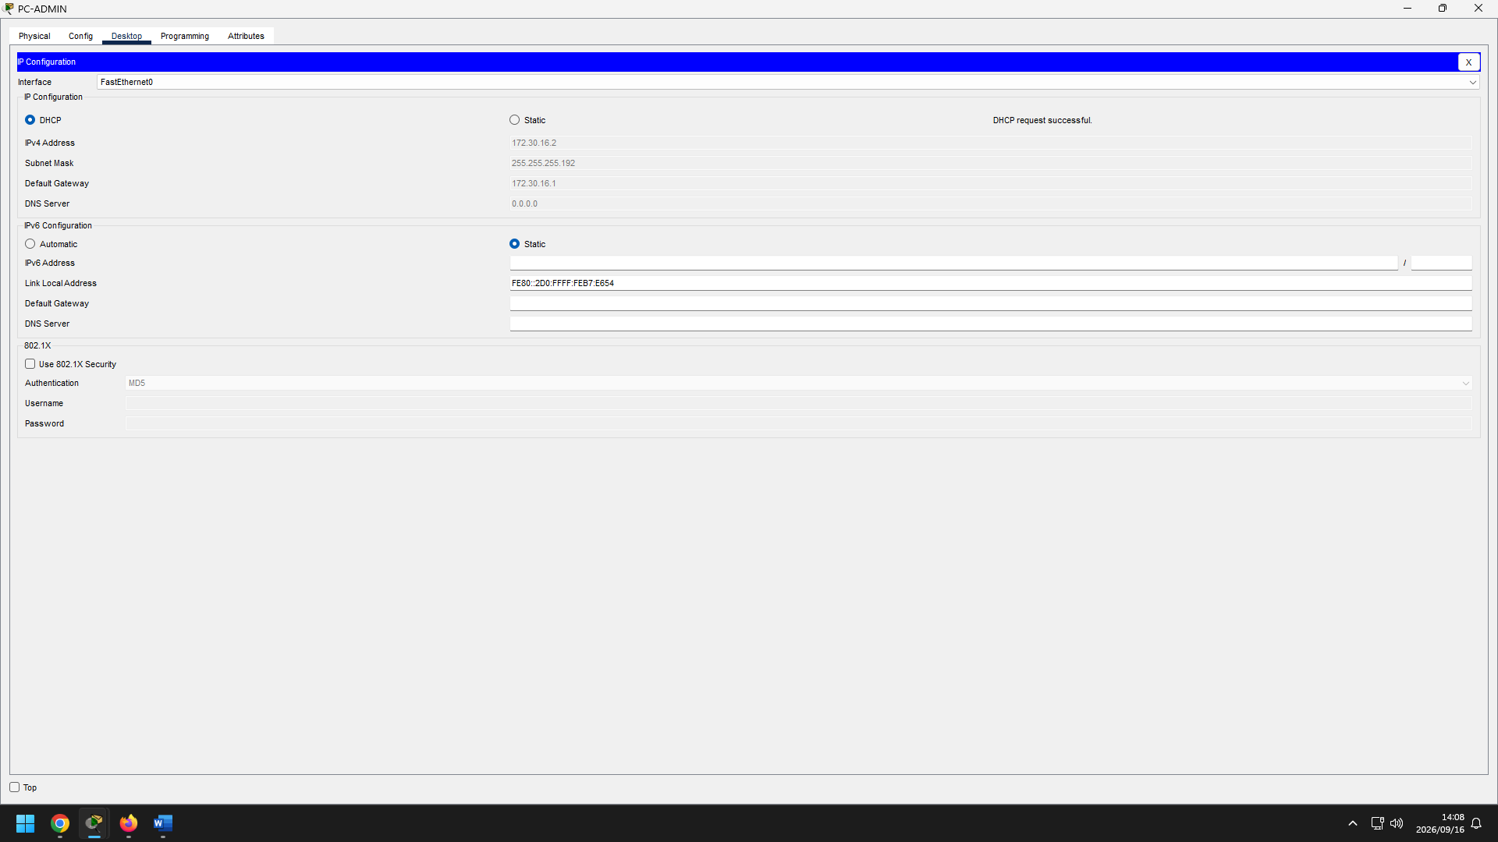
Figure 7: PC-ADMIN IP configuration: lease 172.30.16.2/26, gateway 172.30.16.1
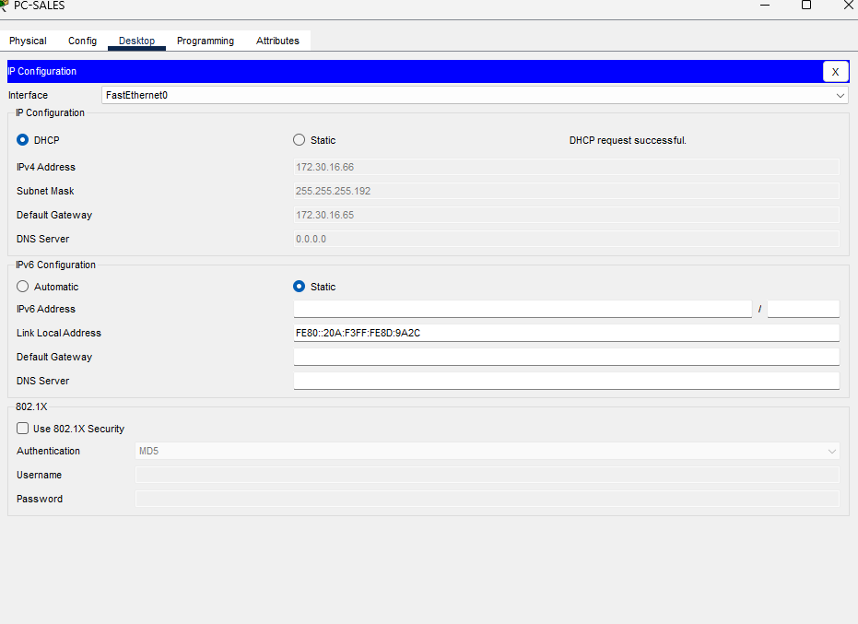
Figure 8: PC-SALES: DHCP lease 172.30.16.66/26
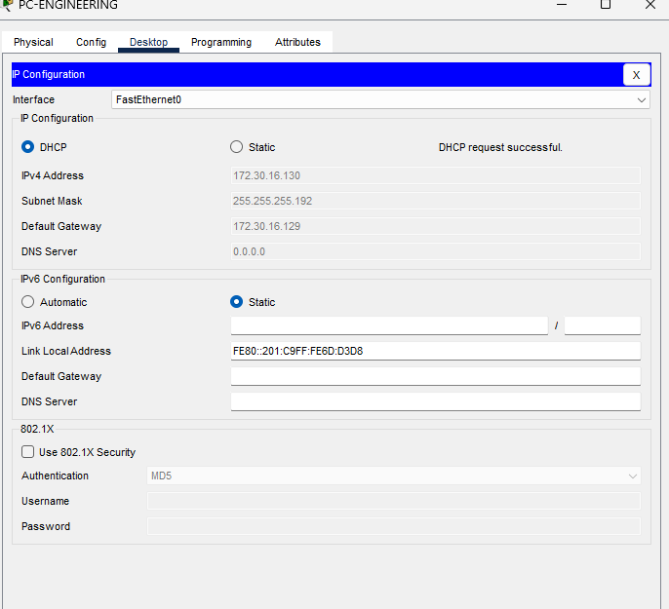
Figure 9: PC-ENGINEERING: DHCP lease 172.30.16.130/26
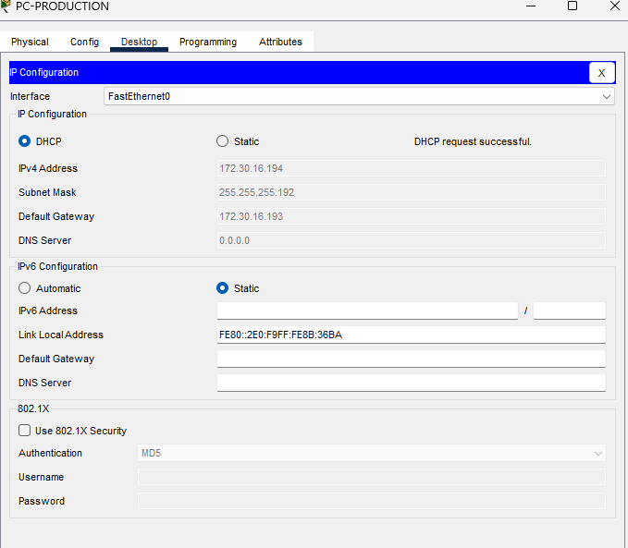
Figure 10: PC-PRODUCTION: DHCP lease 172.30.16.194/26
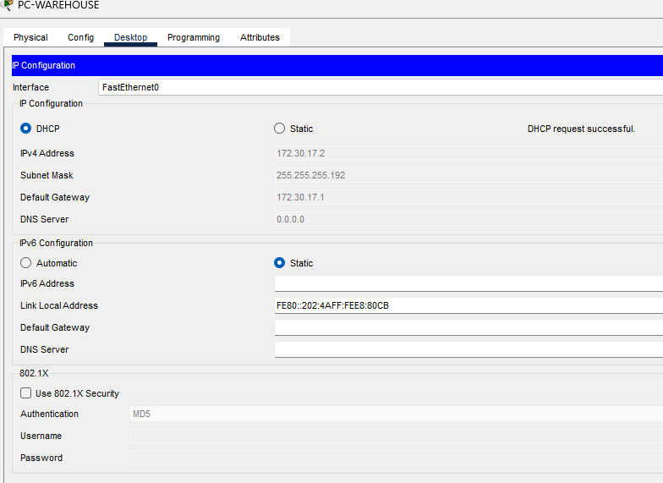
Figure 11: PC-WAREHOUSE: DHCP lease 172.30.17.2/26
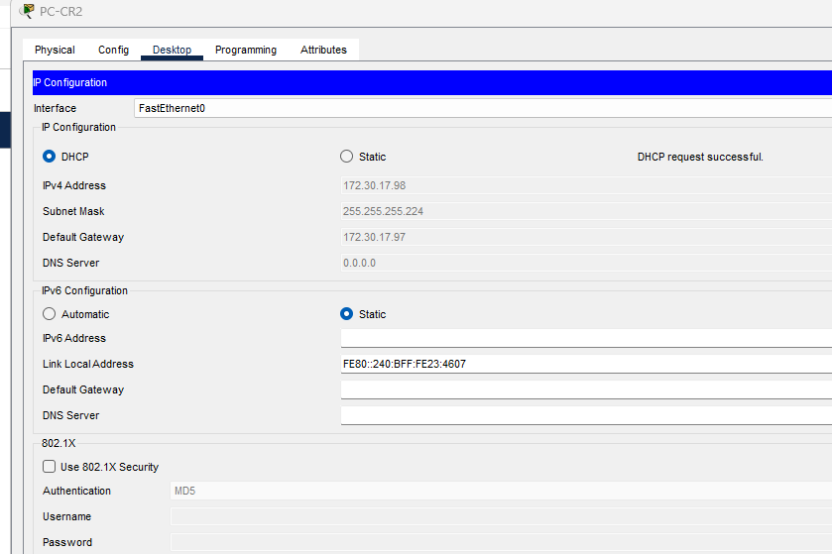
Figure 12: PC-CR2: DHCP lease 172.30.17.98/27
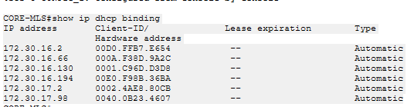
Figure 13: Core DHCP bindings
Figure 14: PC-ENGINEERING: DHCP lease 172.30.16.130/26
Figure 15: PC-PRODUCTION: DHCP lease 172.30.16.194/26
Figure 16: PC-WAREHOUSE: DHCP lease 172.30.17.2/26

Figure 17: PC-CR2: DHCP lease 172.30.17.98/27
Leases were obtained on all six DHCP-enabled VLANs: 172.30.16.2 (Administration), 172.30.16.66 (Sales), 172.30.16.130 (Engineering), 172.30.16.194 (Production), 172.30.17.2 (Warehouse) and 172.30.17.98 (CR2).

5.5 HTTP/Web Server (assigned challenge)
Attribute | Value
Server | SRV-HTTP
VLAN | 60
Address | 172.30.17.66, mask 255.255.255.224
Gateway | 172.30.17.65
Service | HTTP enabled; custom index.html (Tau Metalworks intranet page)

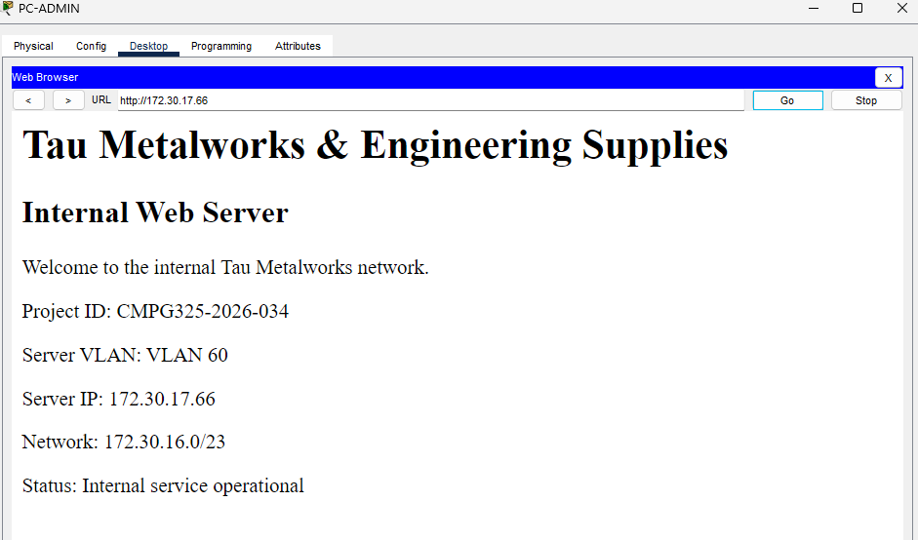
Figure 18: HTTP service accessed from PC-ADMIN (VLAN 10)
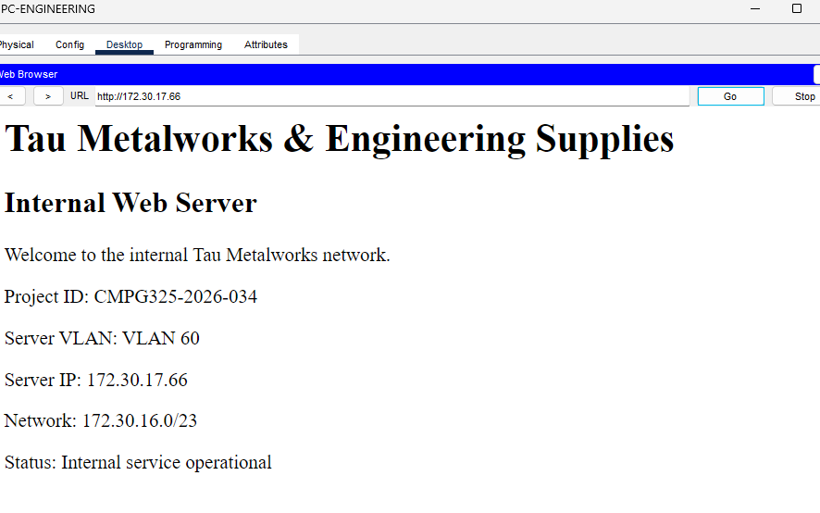
Figure 19: HTTP service accessed from PC-ENGINEERING (VLAN 30)
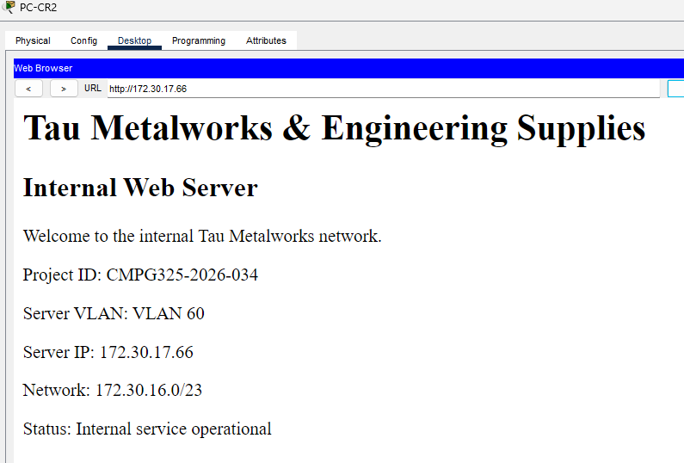
Figure 20: HTTP service accessed from PC-CR2 (VLAN 70)
Access from three VLANs other than the server VLAN confirms that inter-VLAN routing on the Core operates correctly and that the service is available organisation-wide.

5.6 LACP EtherChannel
Two Fast Ethernet links between the Core (Fa0/6, Fa0/7) and SW-SERVER (Fa0/23, Fa0/24) were bundled into Port-Channel 1 using LACP (active mode). The bundle operates as a single Layer-2 trunk allowing VLANs 60 and 99 with native VLAN 99. The Core platform provides only two Gigabit interfaces, so Fast Ethernet ports were used for the bundle.
interface range fastEthernet0/6 - 7
channel-group 1 mode active
interface port-channel 1
switchport mode trunk
switchport trunk native vlan 99
switchport trunk allowed vlan 60,99

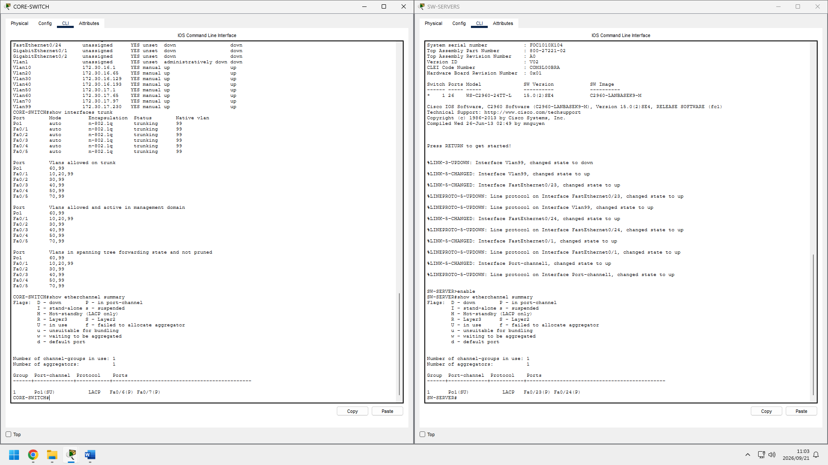
Figure 21: show etherchannel summary: Po1 (SU), LACP, both member ports bundled (P) on both switches

5.7 Change request CR2
The Milestone 1 design reserved a dedicated subnet for the additional floor. Implementation required only the creation of VLAN 70, the SVI 172.30.17.97/27, a DHCP pool, and the connection of SW-NEWFLOOR to the Core by a trunk permitting VLANs 70 and 99. No existing subnet, VLAN or trunk was readdressed, and PC-CR2 obtained 172.30.17.98 and loaded the intranet page.

5.8 Management VLAN
VLAN 99 provides in-band management. Each switch has a static address in 172.30.17.224/28 and a default gateway of 172.30.17.225 (the Core).
Verification of the Core management address (show interface vlan 99):
Vlan99 is up, line protocol is up
Internet address is 172.30.17.225/28
Broadcast address is 255.255.255.255
Address determined by setup command
MTU is 1500 bytes
Helper address is not set
Proxy ARP is enabled

Management reachability of SW-SERVER (172.30.17.230) from the Core. The first attempt lost the initial packets while ARP resolved; the repeat attempt succeeded fully:
CORE-SWITCH#ping 172.30.17.230
Sending 5, 100-byte ICMP Echos to 172.30.17.230, timeout is 2 seconds:
..!!!
Success rate is 60 percent (3/5), round-trip min/avg/max = 0/0/0 ms

CORE-SWITCH#ping 172.30.17.230
Sending 5, 100-byte ICMP Echos to 172.30.17.230, timeout is 2 seconds:
!!!!!
Success rate is 100 percent (5/5), round-trip min/avg/max = 0/0/0 ms

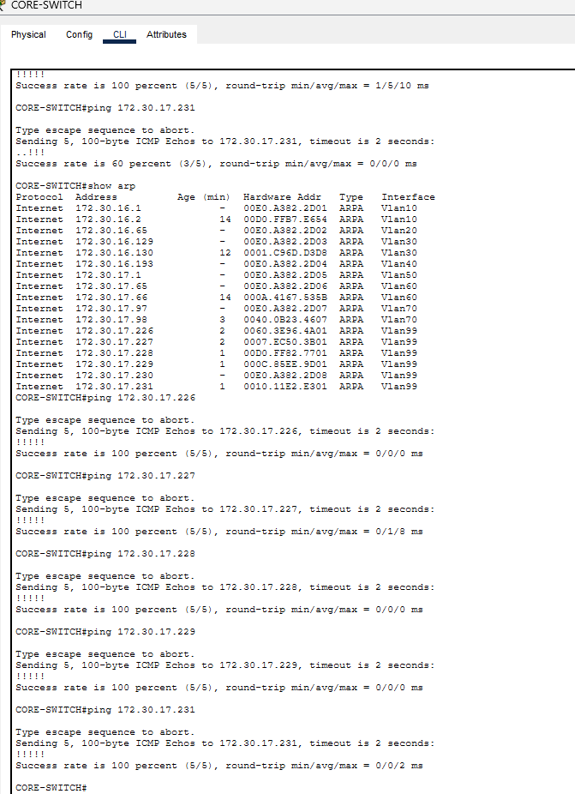
Figure 22: Management VLAN: ARP table and repeated pings to the access-switch addresses

6. Testing and Verification
Fifteen tests were executed in Packet Tracer. Each result below was recorded from observed output, and a PASS was assigned only where the expected result was met.
No. | Test | Expected | Actual result | Status
1 | VLAN verification | Required VLANs exist | VLANs 10, 20, 30, 40, 50, 60, 70, 99 present | PASS
2 | Core SVIs | SVIs up/up | All required SVIs up/up | PASS
3 | Trunking | VLANs carried correctly | Required VLANs permitted on 802.1Q trunks | PASS
4 | EtherChannel | Po1 active, LACP | Po1 active; both links bundled | PASS
5 | DHCP Admin | Correct subnet | 172.30.16.2/26 | PASS
6 | DHCP Engineering | Correct subnet | 172.30.16.130/26 | PASS
7 | DHCP Production | Correct subnet | 172.30.16.194/26 | PASS
8 | DHCP Warehouse | Correct subnet | 172.30.17.2/26 | PASS
9 | DHCP CR2 | Correct subnet | 172.30.17.98/27 | PASS
10 | Inter-VLAN routing | Ping succeeds | Server reached across VLANs; first packet lost to ARP resolution; remainder successful | PASS
11 | HTTP server ping | Reply received | 172.30.17.66 responded | PASS
12 | HTTP from Admin | Page loads | Intranet page loaded | PASS
13 | HTTP from Engineering | Page loads | Intranet page loaded | PASS
14 | HTTP from CR2 | Page loads | Intranet page loaded | PASS
15 | Management VLAN | Switches reachable | All six access-switch addresses (172.30.17.226–.231) returned 100% (5/5) on repeat test; first attempt to .230 lost two packets to ARP resolution | PASS

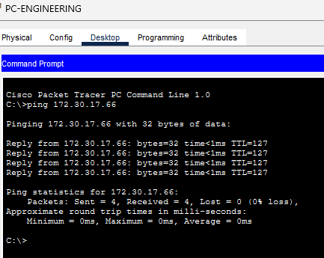
Figure 23: PC-ENGINEERING pinging the HTTP server: 4 of 4 replies, 0% loss
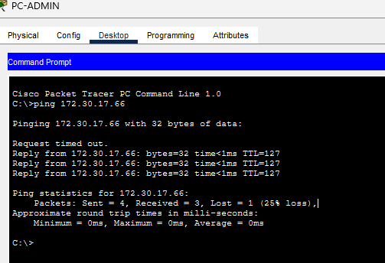
Figure 24: Initial inter-VLAN ping: first packet lost to ARP, remaining packets succeeded
Scope of testing: the tests verify configuration correctness and end-to-end reachability. A physical link-failure test of the EtherChannel (disconnecting one member link while a continuous ping runs) was not performed and no claim of measured failover is made; the redundancy is demonstrated by the verified bundle state only.

7. Troubleshooting Log
No. | Issue observed | Cause | Resolution
1 | "% Invalid input detected" in the Core CLI | Wiring notes (e.g., "CORE-SWITCH Fa0/6 SW-SERVER Fa0/23") were typed into the CLI as if they were commands | Documentation text removed from the CLI; correct interface commands entered in configuration mode
2 | One EtherChannel member link displayed orange while others were green | Spanning Tree places a newly connected link in the listening/learning state before forwarding | Waited for convergence; after LACP negotiation both links bundled and turned green; confirmed with show etherchannel summary
3 | First ping from PC-ADMIN to the server lost one packet (..!!!-style output) | ARP resolution on first contact across VLANs | Repeated the test; ARP table populated and all replies received
4 | Initial management pings returned partial loss | ARP not yet populated | Repeated pings after ARP entries were learned; 100% success
5 | Core VLAN 99 address (.230) differed from plan (.225); .230 was also intended for SW-SERVER | Addressing conflict between planned and configured values | Core set to 172.30.17.225 per plan; SW-SERVER assigned 172.30.17.230; verified with show ip interface brief
6 | Planned Gigabit uplinks unavailable on the Core | The 3560-24PS has two Gigabit ports only | Core uplinks and EtherChannel members moved to FastEthernet ports
7 | Hostname displayed as CORE-MLS | Initial hostname differed from the documented name | Hostname changed to CORE-SWITCH to match all documentation

8. Response to the Availability Constraint
The constraint requires that critical services remain available during business hours. Two complementary measures were applied. At the logical level, the web server resides in VLAN 60 on its own /27 subnet, which isolates it from broadcast traffic originating in user VLANs. At the physical level, SW-SERVER connects to the Core through two LACP-bundled links, so the loss of one cable or port does not remove connectivity to the server segment. Centralised DHCP on the Core, with all VLANs reaching it through trunks, maintains address assignment for every department while the Core is operating.
These measures reduce, but do not eliminate, availability risk. The Core switch remains a single point of failure, which is addressed in Section 10.

9. Security and Management Considerations
- VLAN segmentation: VLANs separate departmental devices into distinct Layer 2 broadcast domains. Communication between different VLANs requires Layer 3 routing through the Core switch, where additional access-control policies could be applied if required.
- Trunk configuration: VLAN 99 is configured as the native VLAN on the trunk links and is used for network management. The allowed VLAN list on each trunk is restricted to the VLANs required for that link, helping to limit unnecessary VLAN traffic.
- Access control: Access Control Lists (ACLs) could be implemented on the Core switch to regulate traffic between the departmental VLANs and the server VLAN. No ACLs were implemented as part of this project.

10. Limitations and Future Work
- Single Core switch: a second Core switch with a redundancy protocol (for example HSRP) would remove the single point of failure.
- Access control lists were not implemented; an ACL on the VLAN 60 SVI restricting traffic to TCP port 80 would harden the server segment.
- DNS was not implemented because it is outside the assigned HTTP/Web Server challenge; the service is accessed by its static address.
- Access-switch uplinks are single links; additional EtherChannels could be added to each floor.
- Failover behaviour was not measured by a link-pull test.
- As a possible future enhancement, secure remote management using SSH could be considered to improve the security of administrative access to network devices. This enhancement was outside the scope of the client's stated requirements and was not implemented during the project.

11. Reflection
The project demonstrated that thorough planning of the address space and VLAN structure at Milestone 1 reduced implementation effort considerably; the CR2 change request was absorbed by a single additional VLAN and trunk precisely because a subnet had been reserved for it. The most instructive difficulties were procedural rather than conceptual: separating documentation notes from CLI input, understanding why a freshly connected link is initially orange under Spanning Tree, and recognising first-packet ARP loss as expected behaviour rather than a fault. Verifying each layer in order (VLANs, trunks, SVIs, DHCP, routing, application) made faults straightforward to isolate.

12. Conclusion
The network for Tau Metalworks & Engineering Supplies was designed, implemented and verified in accordance with the project brief. VLAN segmentation, Layer-3 inter-VLAN routing, centralised DHCP, the internal HTTP service, LACP EtherChannel and the CR2 extension all operate as specified, and fifteen verification tests were passed on the basis of recorded evidence. Known limitations have been stated openly, together with the enhancements that would address them.

Appendix A: Device Inventory
Device | Model / role | Function
CORE-SWITCH | Cisco 3560-24PS, Layer-3 | Inter-VLAN routing, DHCP
SW-GROUND | Cisco 2960-24TT | Administration and Sales
SW-ENG | Cisco 2960-24TT | Engineering
SW-PROD | Cisco 2960-24TT | Production
SW-WARE | Cisco 2960-24TT | Warehouse
SW-SERVER | Cisco 2960-24TT | Server VLAN, Po1 to Core
SW-NEWFLOOR | Cisco 2960-24TT | CR2 floor
SRV-HTTP | Server | HTTP service

Appendix B: Verification Commands
Command | Purpose
show vlan brief | Confirms VLAN creation
show ip interface brief | Confirms SVI addresses and state
show interfaces trunk | Confirms 802.1Q trunks and allowed VLANs
show etherchannel summary | Confirms LACP bundle membership
show ip dhcp binding | Confirms DHCP leases
show ip route | Confirms Core routing table
ping <destination> | Confirms reachability

